**Ch. Rama Karthik Reddy (192472281)**

**15/10/2025 CSA0805 python programming**

**LEVEL 1 QUESTIONS**

**1.Read the number until -1 is encounter. find the avg of positive numbers and negative numbers**

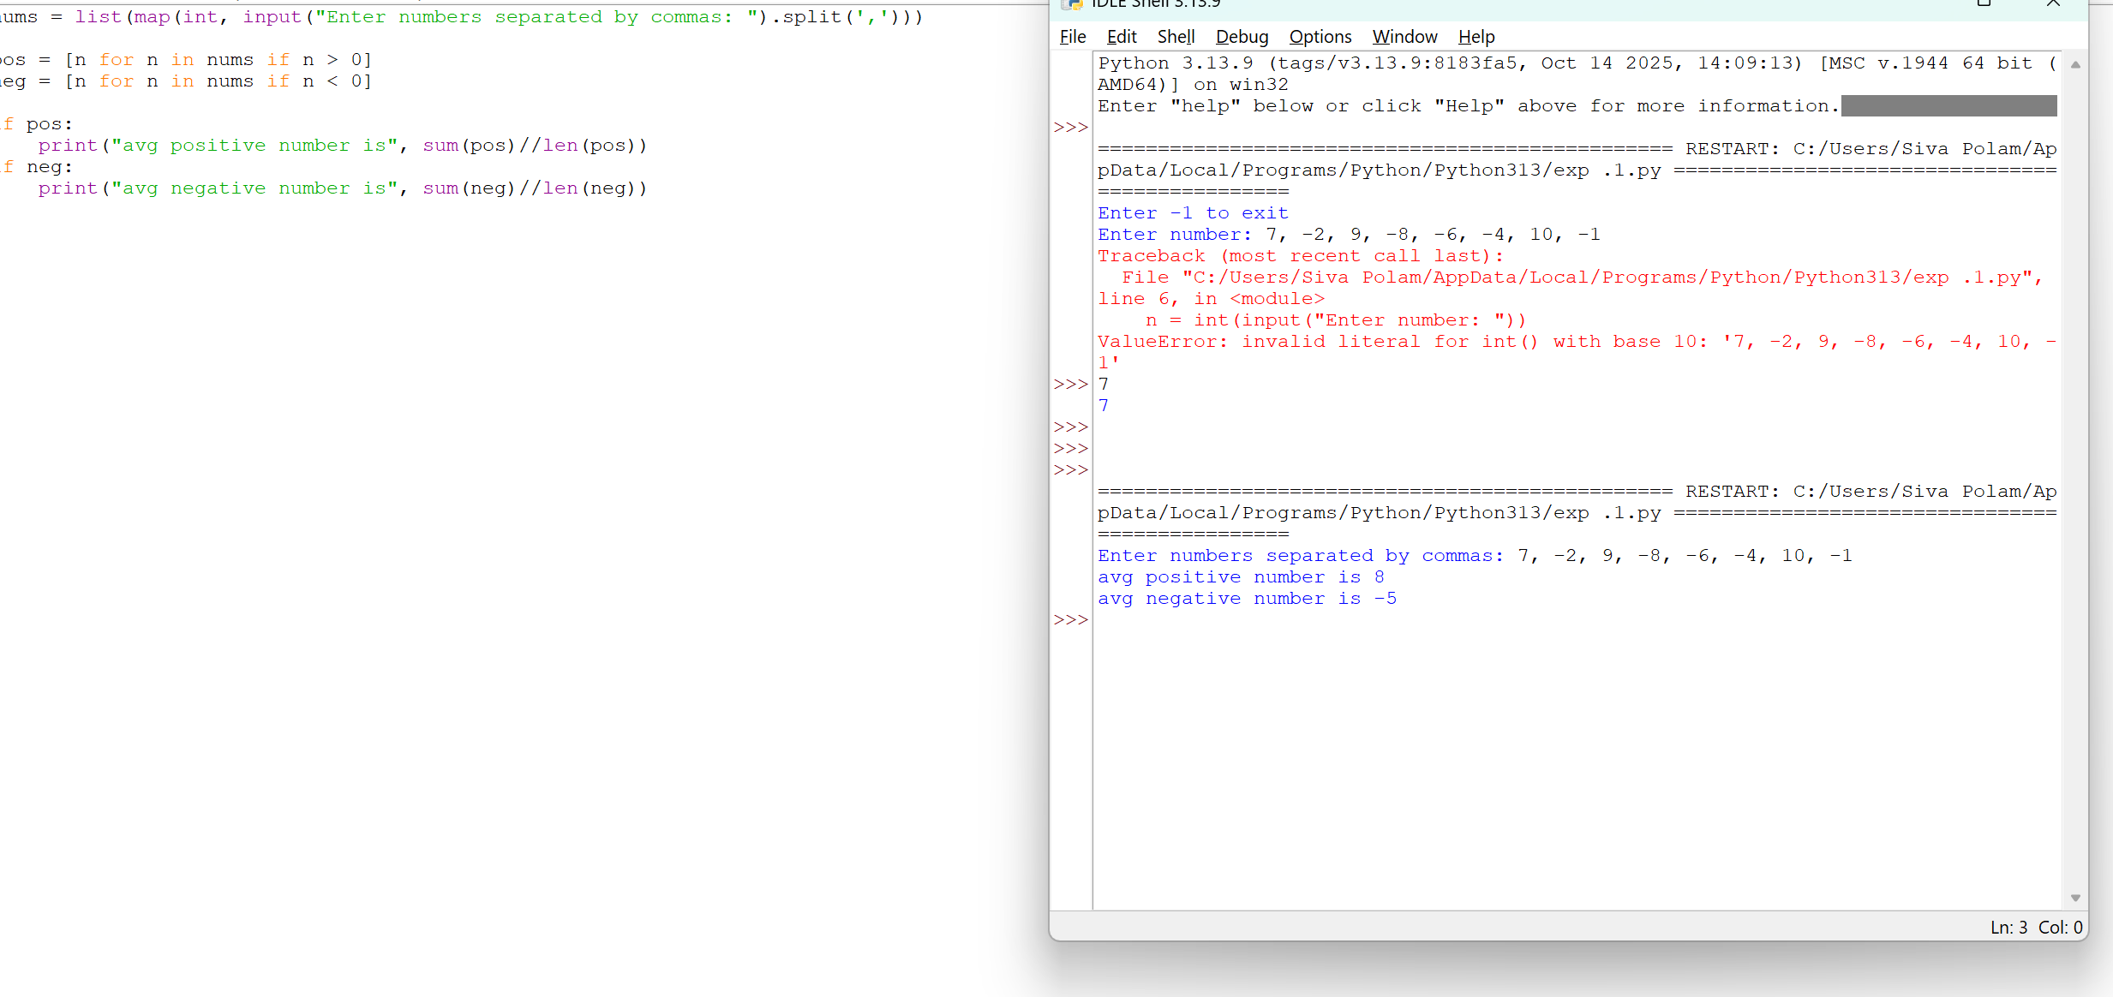

**2. Write a python program to find the square, cube of the given decimal number.**

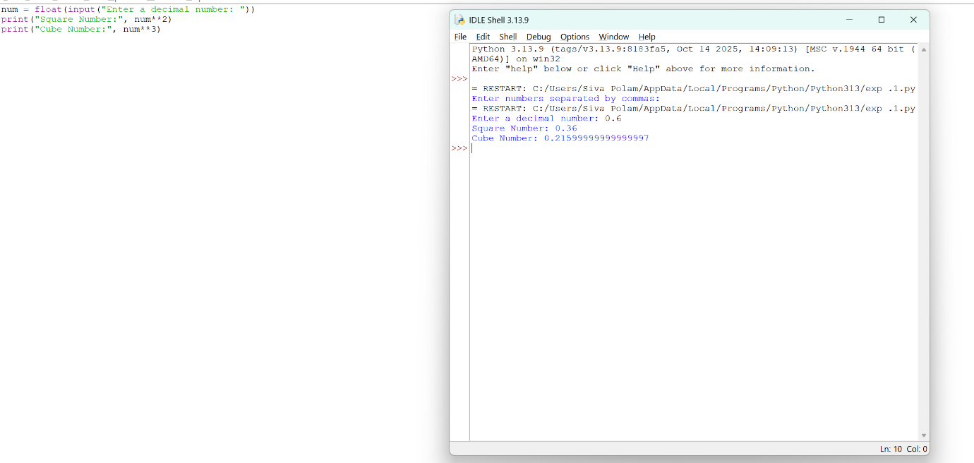

**3. Write a python program to print the following pattern.**

**Sample Input:**

**Enter the Character to be printed:+**

**Number of rows.: 5 Output:**

**+**

**+ +**

**+ + +**

**+ + + +**

**+ + + + +**

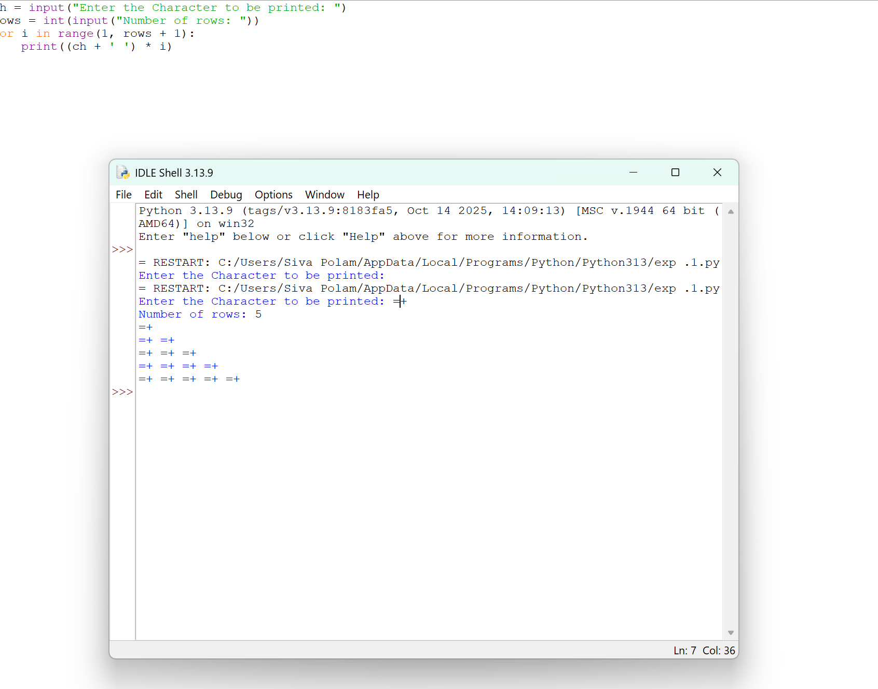

**4. Python Program to Display the Multiplication Table Sample**

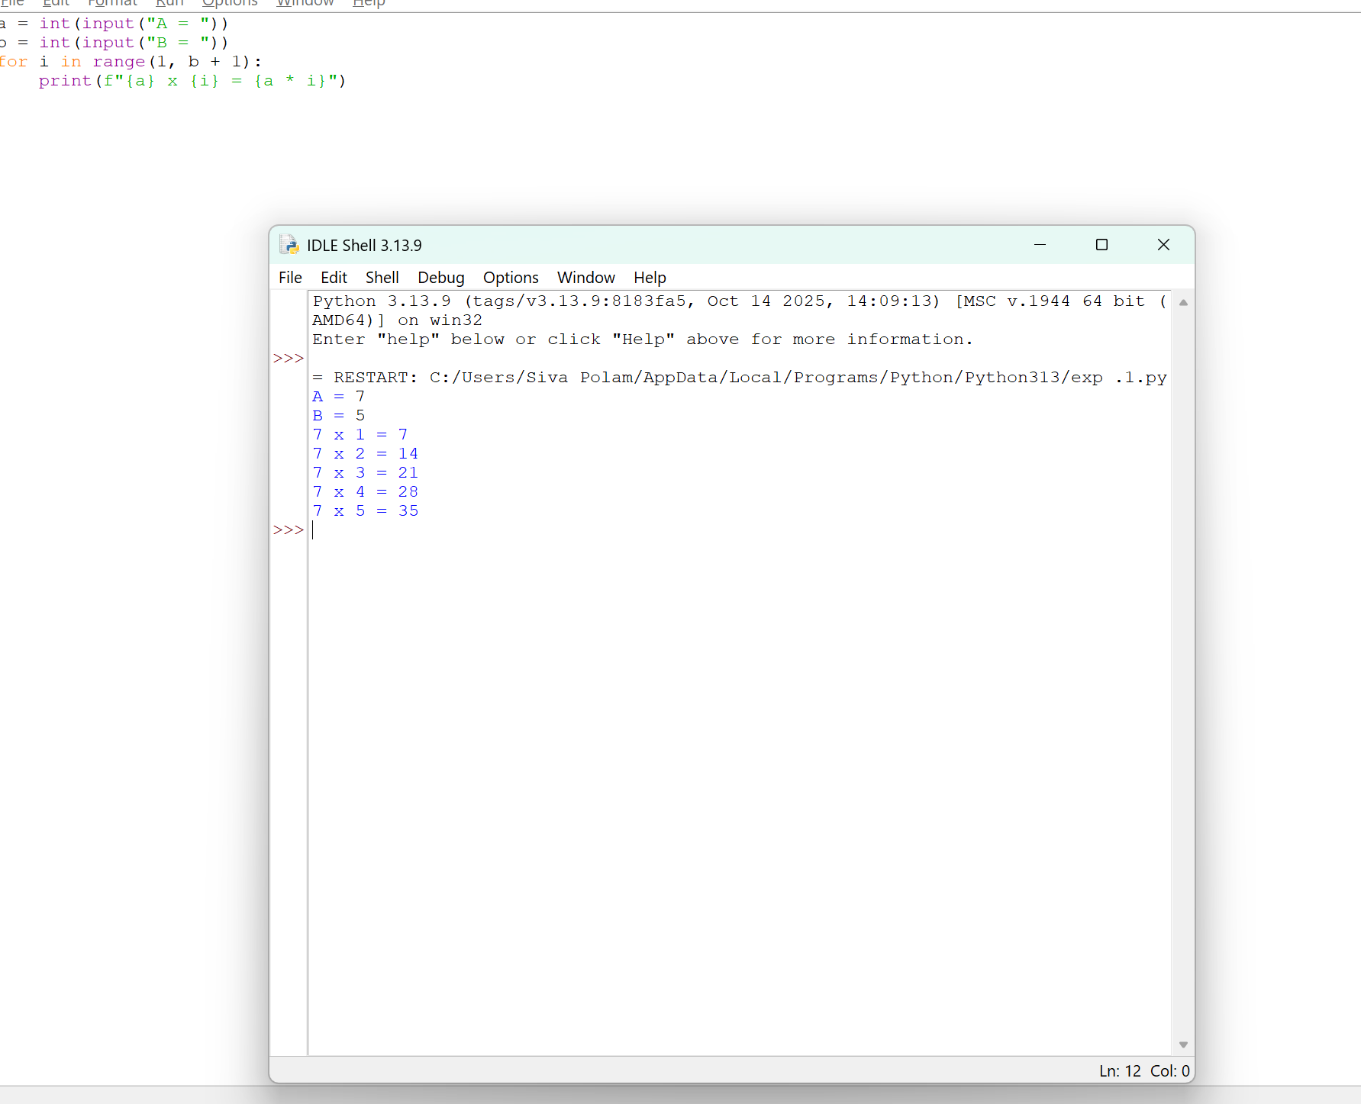

**5. Write a program to find whether it is leap year or not?**

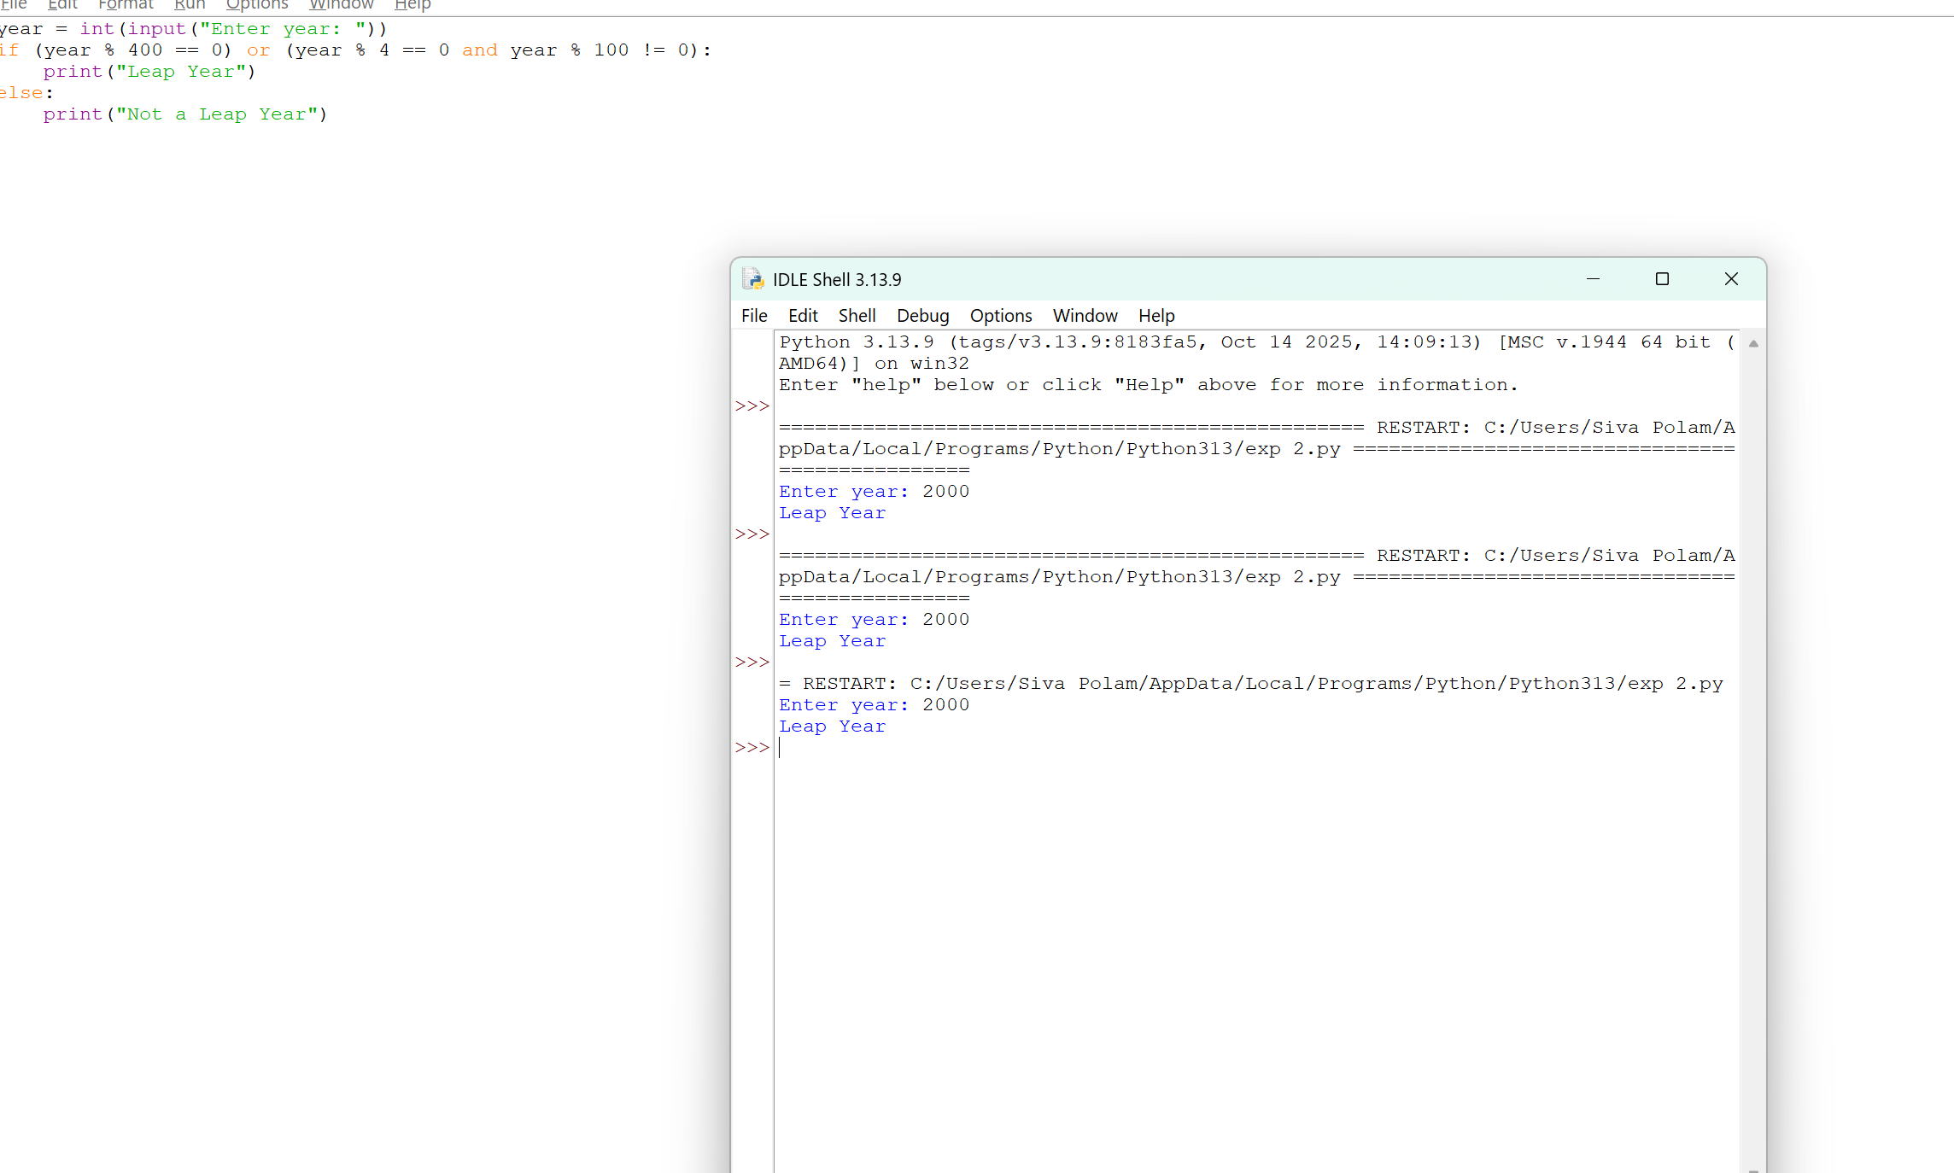

**6.** **Write a program to find out the duplicate array**

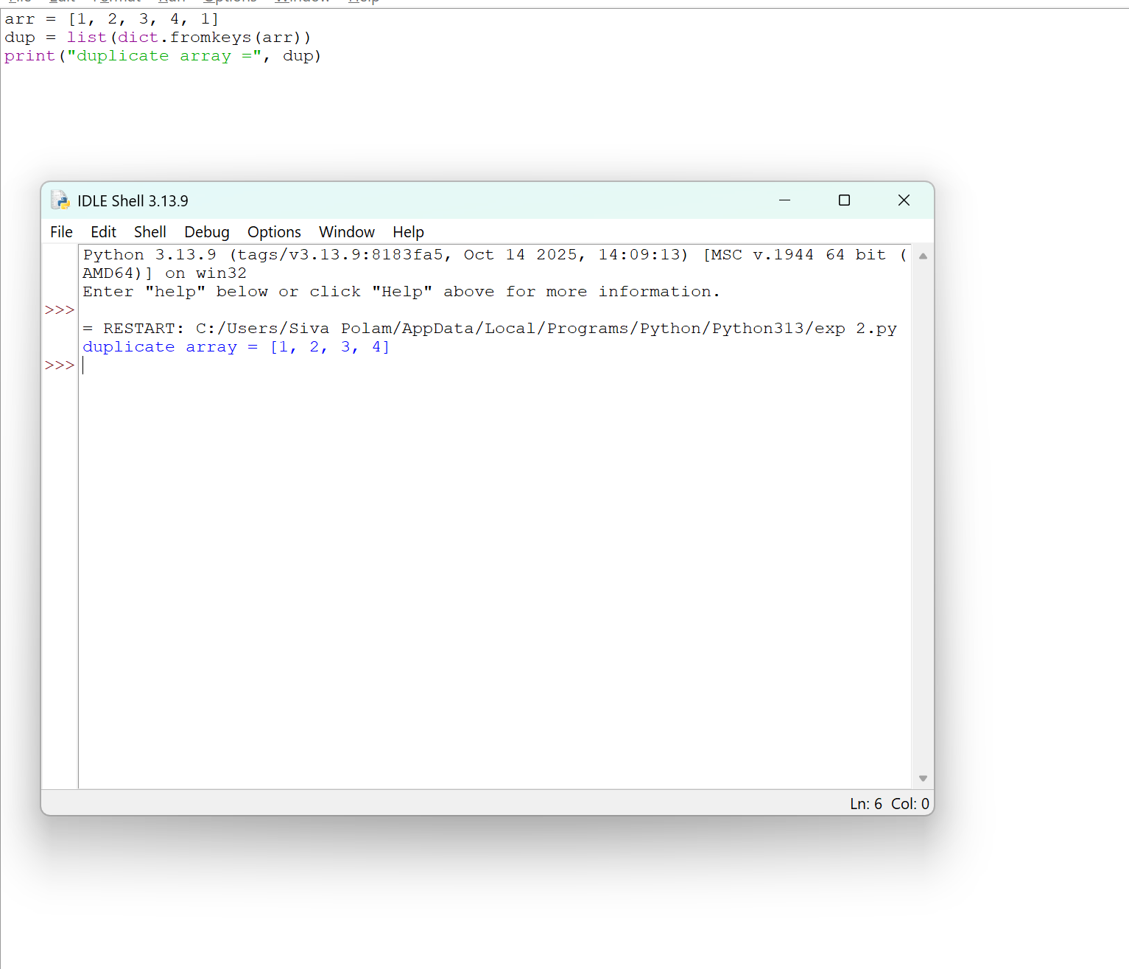

**7.** **Check whether the number is positive or negative**

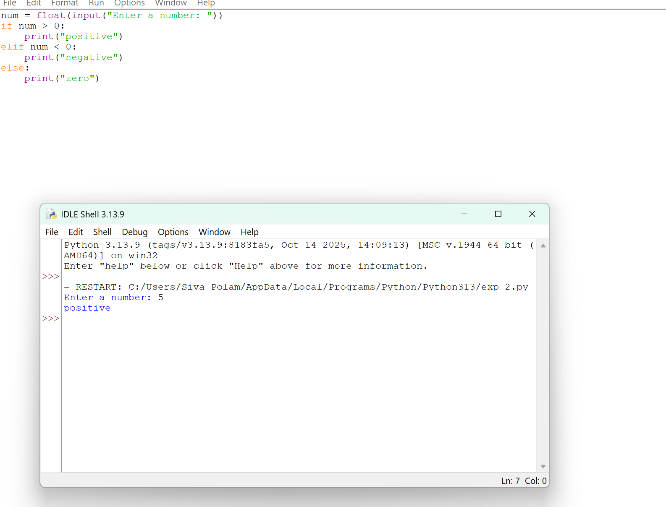

8. **Write a python program to find the average of mean median mode**

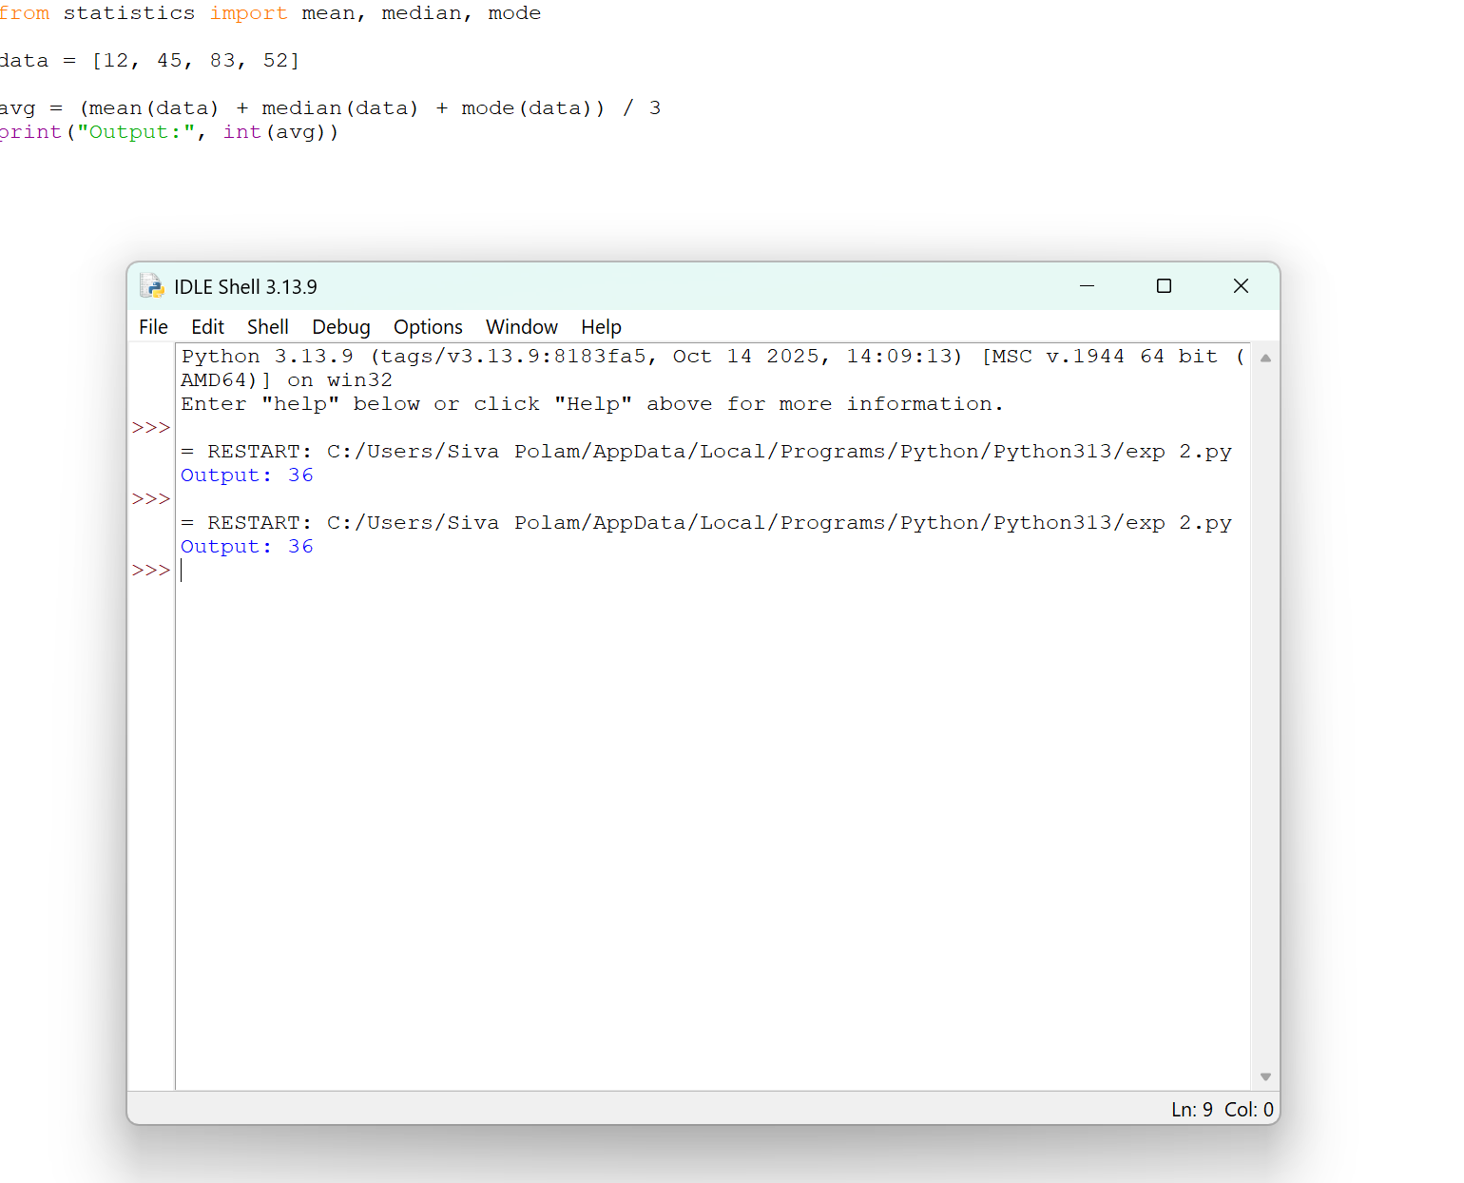

**9. Write a python program to store the arrays in non-increasing order**

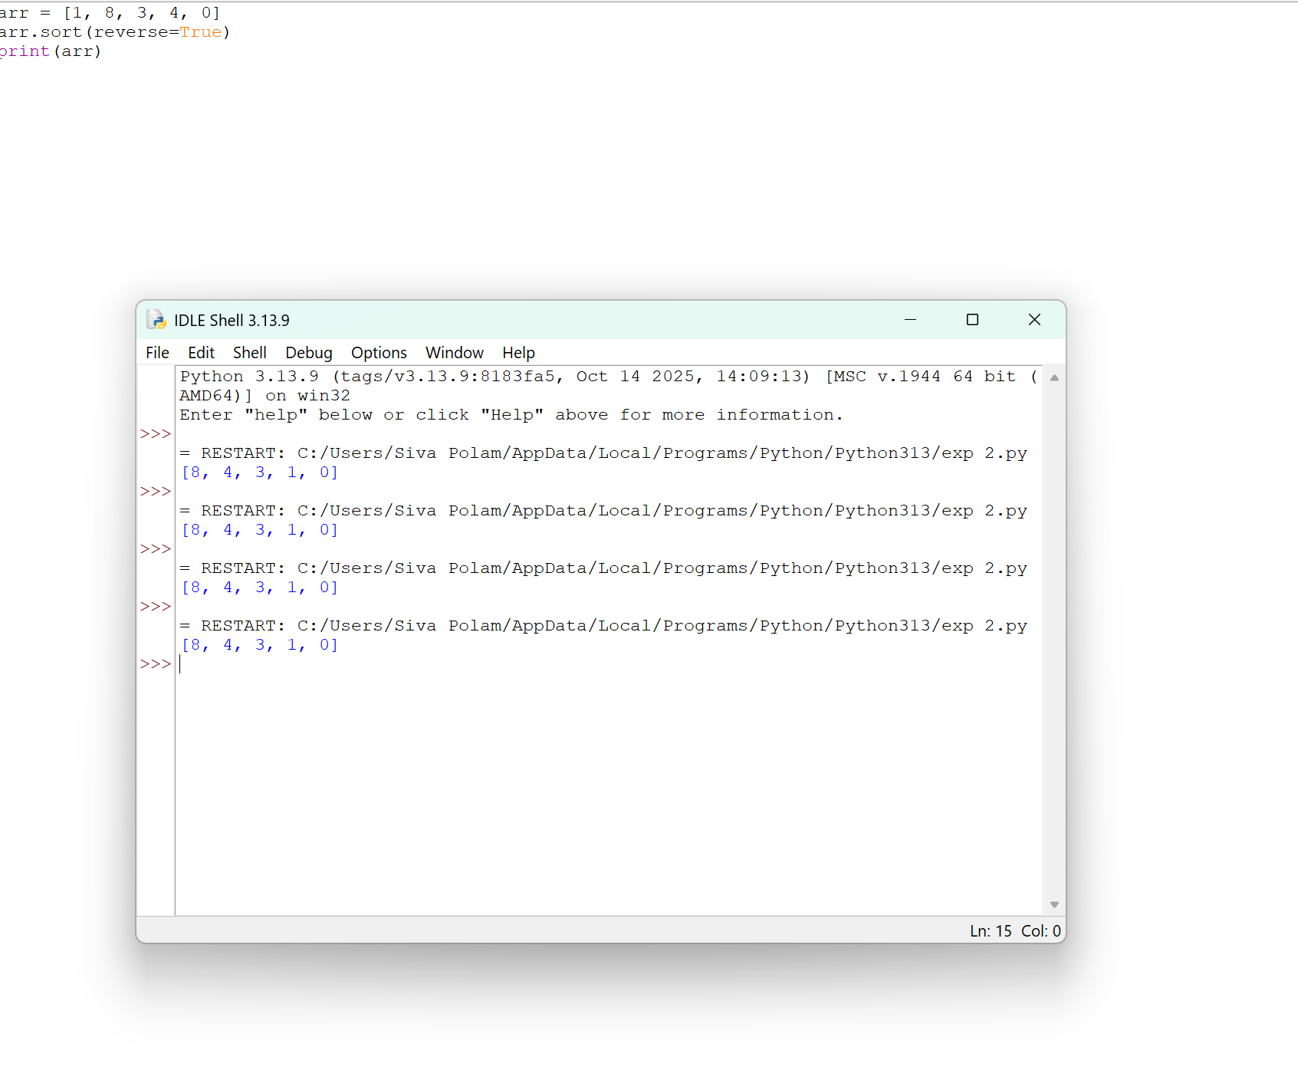

**10. Write a Python Program to Intersecting an elements Sample**

